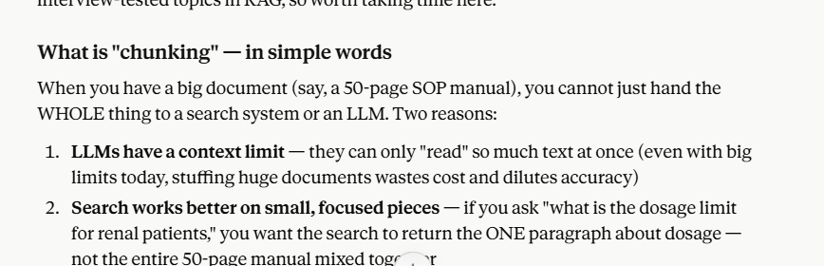

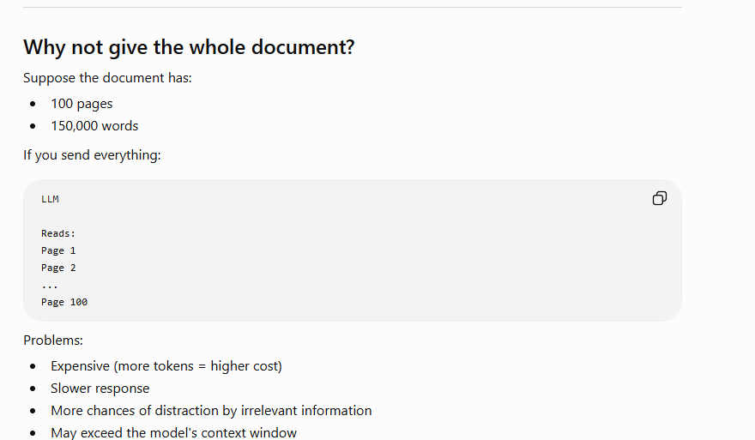

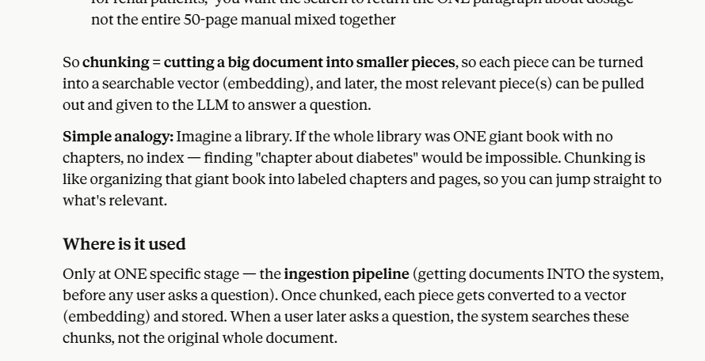

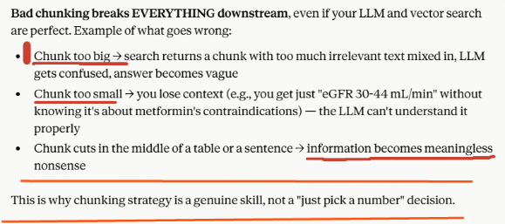

The main strategies — pros, cons, and where each is used
Strategy | How it works | Pros | Cons | Best for
1. Fixed-size chunking | Cut every N characters/tokens (e.g., every 500 words), often with some overlap between chunks | Simple, fast, predictable | Cuts sentences/tables/ideas in half randomly — no respect for meaning | Quick prototypes, not production
2. Sentence/paragraph splitting | Cut only at natural sentence or paragraph breaks | Respects grammar, no mid-sentence cuts | Paragraphs vary wildly in length — some chunks too small, some too big | Simple prose documents
3. Recursive character splitting | Try splitting by paragraph first; if a piece is still too big, split by sentence; if still too big, split by word | Balances size AND natural boundaries automatically | Still doesn't understand MEANING, just structure/punctuation | General-purpose, most common in real projects today
4. Document-structure-aware chunking | Split based on the document's own structure — markdown headers, numbered sections, table boundaries | Keeps a full logical section (like "Step 4.2: SAE Escalation") together as ONE chunk — huge accuracy win for structured docs | Only works well if the document actually HAS clear structure (headers, numbering) | SOPs, guidelines, structured manuals — exactly our healthcare documents!
5. Semantic chunking | Use embeddings to detect where the MEANING shifts (compare consecutive sentences, cut where similarity drops) | Chunks follow actual topic boundaries, not just formatting | Slower, costs more (needs embedding calls just to decide where to cut), harder to explain/debug | High-stakes accuracy needs, research papers with flowing prose
6. Agentic/LLM-based chunking | Ask an LLM itself to read the document and decide chunk boundaries based on understanding | Most "intelligent," can handle very messy documents | Most expensive, slowest, newest (less proven at scale) | Cutting-edge, still maturing — good to KNOW about, risky to over-rely on for a portfolio project

